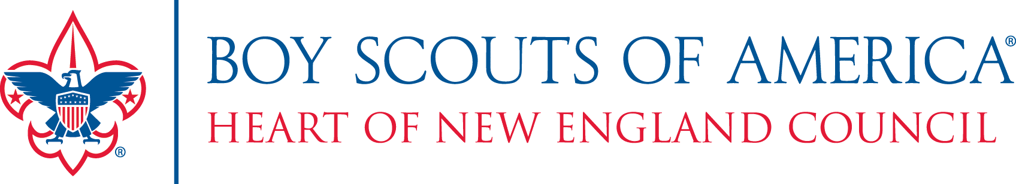
2021 Spring Unit Fundraiser
RIGHT RESPONSE FIRST AID KITS
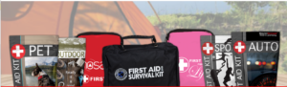
This is the Right Time to
Be Prepared… Everyone needs First-Aid!

Dear Parent,

We are excited to kick off Type in your unit’s primary spring fundraiser, and we need EVERYONE to get involved! To help raise money for summer camp and other outdoor adventures, we are selling First Aid Kits from Right Response.

Here is what you need to know:
- The kits are priced from $15 – $120. Your child will earn 40% from all “take order” sales.
- There is a kit for everyone – homeowners, sports enthusiasts, pet owners, large families, and businesses! There is even a Scout Kit which conforms to “personal first-aid kit requirements” listed in the BSA handbook! These kits make great Mother’s Day, Father’s Day, graduation, and any time of the year gifts. They are also great to have in sports bags, backpacks, cars, purses, etc.
- This will be a take-order sale process! Each Scout will collect the payment when an order is placed.
  - Checks should be made payable to: (Type in Unit Name Here)
- All orders and money are due by: (Type in your unit’s deadline here)
- The kits will be distributed during the week of June 14th.

What is the money used for?
The funds raised will help Scouts to pay for many things such as summer camp, day camp, high-adventure trips, or other Scouting Adventures! This sale provides a 50% return to Scouting. Our Scouts will receive 40% commission on the products sold, while the remaining 10% commission helps Heart of New England Council to provide quality programming to the youth in central MA.

Any questions can be directed to our unit’s Spring Sale Champion:
(Name/Contact Info)
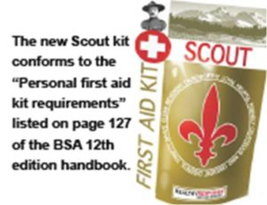
Thank you for your support!!

